1. INTRODUCTION

# PROJECT OVERVIEW

Water is the primary need of all living beings and living without water is impossible. With the advancement of technology and industrialization, environmental pollutions have become a major concern. Water pollution is one of the most serious types of this environmental pollution. Our lives depend on the quality of water that we consume in different ways, from juices which are produced by the industries. Any imbalance in the quality of water would severely affect the humans’ health and at the same time it would affect the ecological balance among all species. Water quality refers to the chemical, biological, radiological, and biological parameters of the water .The essential parameters of the water quality vary based on the application of water. For example, for aquariums, it is necessary to maintain the temperature, pH level, dissolved oxygen level, turbidity, and the level of the water in a certain normal range in order to ensure the safety of the fish inside the aquarium. For the industrial and household applications, however, some parameters of the water are more essential tobe monitored frequently than the others, depending on the usage of the water.

# PURPOSE

To protect, restore, and enhance environmental quality towards good public health, environmental integrity and economic viability.

* As per increase in water pollution there is need of controlling pollution in water is finished by monitoring water quality.
  + Our system consists of various sensors which will compute the standard values of water in real time for effective action and is accurate and only less manpower required.
  + To collect data from various sensor nodes and send it to cloud by IoT and to measure critical chemical and physical parameters of water.
  + System must be a low-cost, most efficient as well as processing, sending and viewing data on cloud through web and mobile.

1. LITERATURE SURVEY

|  |  |  |  |  |
| --- | --- | --- | --- | --- |
| **S. N**  **o.** | **TITLE** | **MODEL/ TECHNIQU ESUSED** | **MERITS**  **/DEMER ITS** | **OUTCO MES** |
| 1. | Y. Wang, I. W. -H. Ho, Y. Chen, Y.Wang and Y. Lin, "**Real-Time WaterQuality Monitoring andEstimationin A IoT for Freshwater BiodiversityConservation**,"inIEEEI nternetofThingsJournal,vol.9,no.1 6,pp.14366-14374,15Aug.15,2022 | * Internetof things. | **Merits:** Prediction error is less than 0.2mg/L.  **Demerit:**  Limited sensorsonly available inmarket. | Monitor waterquality forconservingfr eshwaterbiodiv ersity. |

|  |  |  |  |  |
| --- | --- | --- | --- | --- |
| 2. | S.Chopade,H.P.Gupta,R.Mishra,P.K umariandT.Dutta,"**AnEnergy- EfficientRiverWaterPollutionMoni toring System in Internet ofThings,**" in IEEE Transactions onGreenCommunicationsandNetw orking, vol. 5, no. 2, pp. 693- 702,June2021. | * Internetof things. | **Merits:** Accuracy is high  **Demerit**:  Lessreliable | Estimate and transfer pollution data from river consuming minimum energy. |
| 3. | N.VijayakumarandR.Ramya,(2015) " **The real timemonitoringofwaterqualityinI oT environment, "International**Conference on Circuits, Power andComputing Technologies [ICCPCT-2015] vol. 9, no. 16, pp. 14366-14374,15 | Modulararray ofsensors. | **Merits:**  Interacti ve reports.  **Demerit:**   * Human resource s isrequire d. | Measurescollec ted in sitesconsidered criticalandcruci alfrom anenvironment alpointofview |
| 4. | Y. Qiu, H. Xie, J. Sun and H. Duan,"**ANovelSpatiotemporalDat aModelforRiverWaterQualityVisu alization and Analysis**,"in *IEEE Access*, vol. 7, pp. 155455- 155461,2019. | * Expanding apoint of linesegment. | **Merit**: Spatial points are arranged at equal intervals in the proposed data model.  **Demerit:**  Variationofwa terqualityisun even | Efficientvisualiz ation andadvancedan alysisofRWQdat a. |
| 5. | M. L. Yasruddin, M. Amir HakimIsmail, Z. Husin and W. K. Tan,"**DevelopmentofAutomate dReal- TimeWaterQualityMonitoring and ControllingSystem in Aquarium,**" (2022)IEEE12thSymposiumon Computer Applications &  IndustrialElectronics(ISCAIE),2022. | * Internetofthi ngs. | **Merits:**  High accuracy incollecteddat a. | Excellentreal- time performancean d highpracticabilit y. |
| 6. | N. Kumar Koditala and P. ShekarPandey,(2018) "**Water QualityMonitoring System Using** | * Machi nelear | Thisiseconomi callyaffordabl e | To measure  various |

|  |  |  |  |  |
| --- | --- | --- | --- | --- |
|  | **IoT andMachine Learning**," InternationalConferenceonResear chinIntelligentandComputinginEng ineering (RICE),,pp.1-5, | ning   * Internet ofThings   CloudAzure | forcommonpe ople.Accuracy inmeasureme nt.  Emailalertisse nttouser | chemical and physical properties of water like pH, temperatu re and particle density of water using  sensors. |
| 7. | H.H.Kenchannavar, P.M.Pujar,R.  M. Kulkarni and U. P. Kulkarni,(2022)**"Evaluation and Analysis ofGoodness of Fit for Water QualityParametersUsingLinearRe gression Through the Internet-of- Things-Based Water**  **QualityMonitoringSystem,”**inIEEEI nternetofThings Journal, vol. 9,no. 16, pp. 14400-14407,  doi:10.1109/JIOT.2021.3094724. | * Interneto fthings.   GSM/GPRSboard(S IM800A)isinterfac edwith ESP32using UARTinterface. | High accurate andconventio nalwaterquali ty testingtechni ques | To measurevarious chemicaland physicalproperti esofwater like pH,temperature andparticle densityof water usingsensors. |

# EXISTING PROBLEM

* + - Technique is very high due to the operation cost, labor cost and equipment cost, and it is difficult to make critical decisions in the real time.
    - What we need to find out in the water quality that require faster in results so that can be make possible utilization in real world application weather changes may change quality of water so we need to concentrate at a faster rate.
    - To overcome the drawbacks of the conventional water quality monitoring methods, sensors can be used. Sensor is an ideal detecting device which can convert non-power information to electrical signals which can easily be processed, transformed.

# REFERENCE

1K. S. Adu-Manu, C. Tapparello, W. Heinzelman, F. A. Katsriku and J.-D. Abdulai, "Water quality monitoring using wireless sensor networks: Current trends and future research directions", ACM Trans. Sens. Netw., vol. 13, no. 1, pp. 4, 2017

1. P. Salunke and J. Kate, "Advanced smart sensor interface in Internet of Things for water quality monitoring", Proc. Int. Conf. Data Manag. Anal. Innovat. (ICDMAI), pp. 298-302, 2017, 2017
2. S. Behmel, M. Damour, R. Ludwig and M. J. Rodriguez, "Water quality monitoring strategies—A review and future perspectives", Sci. Total Environ., vol. 571, pp. 1312-1329, Nov. 2016.
3. T. I. Salim, H. S. Alam, R. P. Pratama, I. A. F. Anto and A. Munandar, "Portable and online water quality monitoring system using wireless sensor network", Proc. 2nd Int. Conf. Autom. Cogn. Sci. Opt. Micro Electro Mechan. Syst. Inf. Technol. (ICACOMIT), vol. 2018, pp. 34-40, Jan. 2018

# PROBLEM STATEMENT DEFINITION

Due to the fast growing urbanization supply of safe drinking water is a challenge for the every city authority. Water can be polluted any time. So the water we reserved in the water tank at our roof top or basement in our society or apartment may not be safe. Still in India most of the people use simple water purifier that is not enough to get surety of pure water. Sometimes the water has dangerous particles or chemical mixed and general purpose water purifier cannot purify that. And it’s impossible to check the quality of water manually in every time. So an automatic real-time monitoring system is required to monitor the health of the water reserved in our water tank of the society or apartment. So it can warn us automatically if there is any problem with the reserved water. And we can check the quality of the water anytime and from anywhere. By keeping this mind we designed this system especially for residential areas.

1. IDEATION & PROPOSED SOLUTION

# EMPATHY MAP CANVAS

* 1. **IDEATION & BRAINSTORMING**

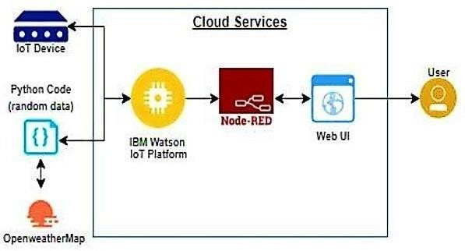

# PROPOSED SOLUTION

The main aim is to develop a system for continuous monitoring of river water quality at remote places using wireless sensor networks with low power consumption, low-cost and high detection accuracy. pH, conductivity, turbidity level, etc. are the limits that are analyzed to improve the water quality.

Following are the aims of idea implementation

1. To measure water parameters such as pH, dissolved oxygen, turbidity, conductivity, etc. using available sensors at a remote place.
2. To assemble data from various sensor nodes and send it to the base station by the wireless channel.
3. To simulate and evaluate quality parameters for quality control.
4. To send SMS to an authorized person routinely when water quality detected does not match the preset standards, so that, necessary actions can be taken. The detailed scheme of a water quality monitoring system. In the proposed architecture, each water reservoir will be attached with a sensor node equipped with a set of sensor probes capable of measuring the parameters like pH, turbidity etc. According to the specifications of the sensor probes and the processor board of the sensor the signal conditioning circuit will be designed to generate the sensor output to the processor board through Analog to Digital Converter. The processor board processes the data according to the quality specifications and transmits to the central server through the transceiver. The measured data in each of the reservoir shall be sent to the central server through the respective transceivers either directly or indirectly through other sensor or repeater nodes

# PROBLEM SOLUTION FIT

DEFINE CS, FIT INTO CC

* + - Customer Segment(S) CS
    - Customer Constraints CC
    - Available Solutions

FOCUS ON J&P, TAP INTO BE, UNDERSTAND RC

* + - Problem Root Cause RC
    - Behaviour BE

IDENTIFY STRONG TR & EM

* + - Triggers TR

YOUR SOLUTION

* + - Channels Of Behaviour
    - Emotions: Before / After

1. REQUIREMENT ANALYSIS

|  |  |  |  |
| --- | --- | --- | --- |
| **S.No** | **Component** | **Description** | **Technology** |
| 1. | UserInterface | Howuserinteractswithapplica tione.g.  WebUI, MobileApp,Chatbotetc. | HTML,CSS,Node-Red,Cloud,etc. |
| 2. | ApplicationLogic-1 | Logicforaprocessintheapplica  tion | Java/Python |
| 3. | ApplicationLogic-2 | Logicforaprocessintheapplica  tion | IBMWatsonSTTservice |
| 4. | ApplicationLogic-3 | Logicforaprocessintheapplica  tion | IBMWatsonAssistant |
| 5. | Database | DataType,Configurationsetc. | MySQL,NoSQL,etc. |
| 6. | CloudDatabase | DatabaseServiceonCloud | IBMDB2,IBMCloudantetc. |
| 7. | FileStorage | Filestoragerequirements | IBMBlock StorageorOtherStorageServiceo  rLocalFilesystem |
| 8. | ExternalAPI-1 | PurposeofExternalAPIusedint  heapplication | IBMWeatherAPI,etc. |
| 9. | ExternalAPI-2 | Purposeof  ExternalAPIusedintheapplicat ion | AadharAPI,etc. |
| 10. | MachineLearningM  odel | PurposeofMachineLearning  Model | ObjectRecognitionModel,etc. |
| 11. | Infrastructure(Serve r/Cloud) | Application Deployment on Local System / CloudLocalServer  Configuration: CloudServerConfiguration: | Local,CloudFoundry,Kubernetes,etc. |

# FUNCTIONAL REQUIREMENT Functional Requirements:

**Following are the functional requirements of the proposed solution. FR-1: Users Authorization levels**

# Complete mapping are given in a hierarchicalmanner in order to show only the specific Data.

**FR-2: Historical Data**

# The Data are stored in the cloud from the beginning Stage till the Updation .

**FR-3: User Authentication**

# The credentials is accessible only to the authorizedusers to access the model.

**FR-4: Users rules and laws**

# There is some specific guidelines which has to be followed by the users.

* 1. **NON-FUNCTIONAL REQUIREMENTS**

**Non-functional Requirements:**

**Following are the non-functional requirements of the proposed solution. NFR-1: Usability**

# The Final data should be easily understandable.

**NFR-2: Security**

# The model are designed in a secured manner inorder to maintain the privacy

**NFR-3: Reliability**

# Even if there is a firmware issues (failures) the updated Data’s are stored in a Default manner.

**NFR-4: Performance**

# High quality sensors are used to ease thecustomer’s work.

**NFR-5: Availability**

# The model are designed in such a way that areavailable ,usable and can be modified anytime.

**NFR-6: Scalability**

# The System are Scaled according to the size ofthe water body (varies)

1. PROJECT DESIGN

# DATA FLOW DIAGRAMS

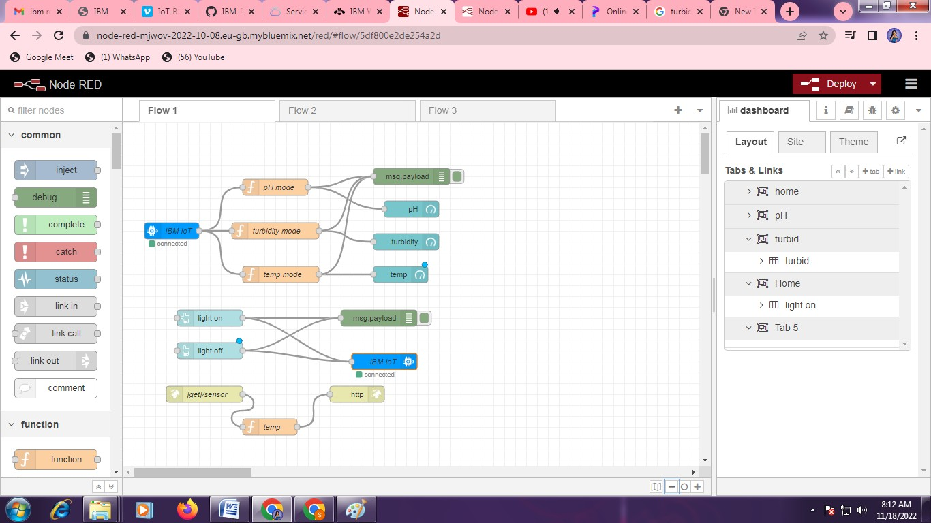

* 1. **SOLUTION &TECHNICAL ARCHITECTURE Solution Architecture:**

Solution architecture is a complex process – with many sub-processes – that bridges the gap between business problems and technology solutions. Its goals are to:

* Find the best tech solution to solve existing business problems.
* Describe the structure, characteristics, behaviour, and other aspects of the
* software to project stakeholders.
* Define features, development phases, and solution requirements.
* Provide specifications according to which the solution is defined, managed,
* and delivered.

Example - Solution Architecture Diagram:

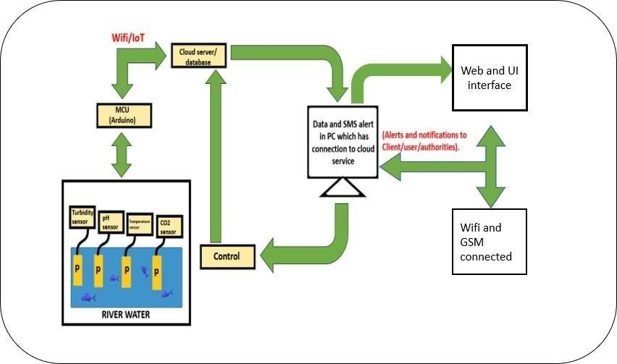

# TECHNICAL ARCHITECTURE:

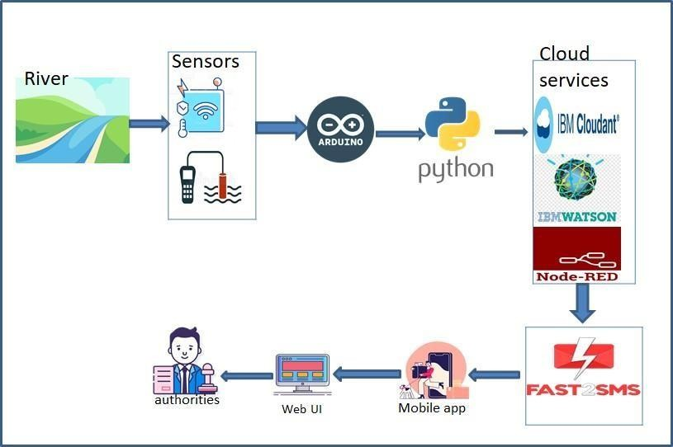

**The Temperature and PH sensor**.

To measure the temperature of a water tank and log it via the Arduino. The idea is to maintain the temperature of the water at 25-30C at all times. I've noticed that most applications have used a sensor such as DS18S20 or TMP35/TMP36/TMP37. but since my application requires to measure the temperature in water, I think a more suitable sensor should have a waterproof probe (or external probe).

The usual way is to contain the water inside a tank / container which can transmit heat – usually metal. To the outside of this is then bonded the temperature sensor – be that a simple bi- metallic strip thermostat, or a more complex temperature sensing transducer. Of course, this requires a metal tank, and that will radiate heat, which will be wasteful. Ideally you would want some form of waterproof probe. You haven't mentioned the amount of water you're dealing with – how big is the tank? How deep especially.There

are thermocouples available in a rigid probe form – quite how waterproof these are I'm not sure, but these are never very long, so you won't be able to get it more than 6 inches or so into the water before you risk complete submersion.

# The Turbidity Sensor

Turbidity is an indicator often used to find the amount of suspended sediment in water. By cumbersome mechanicalsampling, it is possible to measure the concentration of suspended solids (in mg/ l) in water, but turbidity is increasingly used instead, as it is easy to use and cheaper too. It is an ecologically important parameter as the various effects of suspended solids in aquatic ecosystems are due to their light scattering properties rather than their absolute mass

1. PROJECT PLANNING & SCHEDULING

# SPRINT PLANNING & ESTIMATION

Milestone and Activity List

|  |  |
| --- | --- |
| Date | 14 October 2022 |
| Team ID | PNT2022TMID49191 |
| Project Name | Real time river water quality controlling and monitoring system |

|  |  |  |
| --- | --- | --- |
| TITLE | DESCRIPTION | DATE |
| Literature Survey & Information Gathering | Literature survey on the selected project is done by gathering information about related details on technical papers and web browsing | 28 SEPTEMBER 2022 |
| Empathy Map | Prepare Empathy Map Canvas to combine thoughts and pains, gains of the project with all team members | 24 SEPTEMBER 2022 |

|  |  |  |
| --- | --- | --- |
| Ideation | Brainstorming session is conducted with all team members to list out all the ideas and prioritise the top 3 ideas | 25 SEPTEMBER 2022 |
| Proposed Solution | Prepare the proposed solution document, which includes the novelty, feasibility of idea, business model, social impact, scalability of solution, etc. | 23 SEPTEMBER 2022 |
| Problem Solution Fit | Prepare problem - solution fit document. | 30 SEPTEMBER 2022 |
| Solution Architecture | Prepare solution architecture document with basic design ideas | 28 SEPTEMBER 2022 |
| Customer Journey | Prepare the customer journey maps to understand the user interactions & experiences with the application | 20 OCTOBER 2022 |
| Functional Requirement | functional requirement is prepared with listing both functional and non -functional  needs | 8 OCTOBER 2022 |
| Data Flow Diagrams | Draw the data flow diagrams and submit user stories | 9 OCTOBER 2022 |
| Technology Architecture | Prepare architecture with components & technologies, | 10 OCTOBER 2022 |
| Prepare Milestone & Activity List | Prepare the milestones & activity list of the project. | 22 OCTOBER 2022 |

|  |  |  |
| --- | --- | --- |
| Project Development - Delivery of Sprint-1, 2, 3 & 4 | Develop & submit the developed code by testing it. | IN PROGRESS.. |

* 1. **SPRINT DELIVERY SCHEDULE**

|  |  |
| --- | --- |
| DATE | 14 October 2022 |
| TEAM ID | PNT2022TMID49206 |
| PROJECT NAME | Real-Time River Water Quality Monitoring and  Control System |
| MAXIMUM MARKS | 8 MARKS |

**Product Backlog, Sprint Schedule, and Estimation (4 Marks)**

|  |  |  |  |  |  |  |
| --- | --- | --- | --- | --- | --- | --- |
| **Sprint** | **Functional Requirement(Epic)** | **User Story Number** | **User Story/Task** | **Story Points** | **Priority** | **Team Members** |
| Sprint 1 | Registration | USN-1 | As a user, I can register for the application by entering my email, password, and confirming my password. | 2 | High | Deepak |
| Sprint-1 |  | USN-2 | As a user, I will receive confirmation email once I have registered for the application | 1 | High | Indhurjith |

|  |  |  |  |  |  |  |
| --- | --- | --- | --- | --- | --- | --- |
| Sprint-2 |  | USN-3 | As a user, I can register for the application through Facebook | 2 | Low | Kishore kumar |
| Sprint-1 |  | USN-4 | As a user, I can register for the application through Gmail | 2 | Medium | Sheik abudulla |
| Sprint-1 | Login | USN-5 | As a user, I can log into the application by Entering email & password | 1 | High | Deepak |

**Project Tracker, Velocity & Burndown Charts (4 Marks):**

|  |  |  |  |  |  |  |
| --- | --- | --- | --- | --- | --- | --- |
| **Sprint** | **Total Story Points** | **Duration** | **Sprint Start Date** | **Sprint End Date (Planned)** | **Story Points Completed (as on**  **Planned End Date)** | **Sprint Release Date (Actual)** |
| Sprint-1 | 20 | 6 Days | 24 Oct 2022 | 29 Oct 2022 | 20 | 29 Oct 2022 |
| Sprint-2 | 20 | 6 Days | 31 Oct 2022 | 05 Nov 2022 | 30 | 30 Oct 2022 |
| Sprint-3 | 20 | 6 Days | 07 Nov 2022 | 12 Nov 2022 | 49 | 06 Nov 2022 |
| Sprint-4 | 20 | 6 Days | 14 Nov 2022 | 19 Nov 2022 | 50 | 07 Nov 2022 |

# REPORTS FROM JIRA

1. CODING & SOLUTIONING PYTHON CODE

# import random

**print(&#39;Hazardous Water Level=&#39;,str(random.randint(0,100))) print(&#39;Temperature=&#39;,str(random.randint(0,100))) print(&#39;Humidity=&#39;,str(random.randint(0,100))) print(&#39;Pressure=&#39;,str(random.randint(0,100)))**

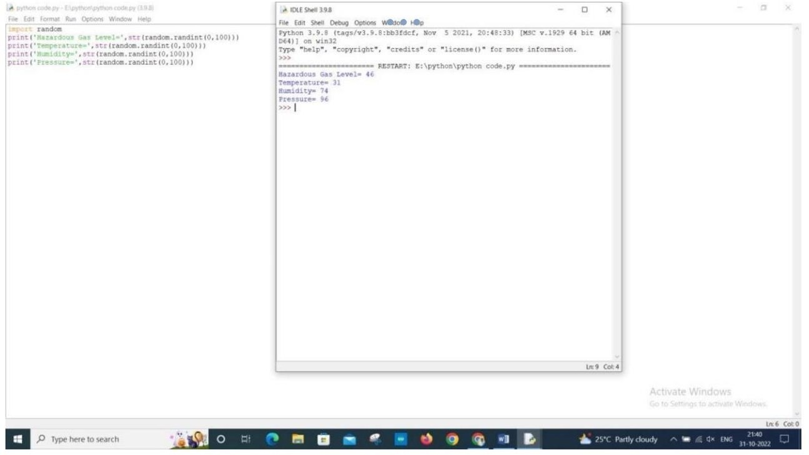

1. TESTING

# TEST CASE

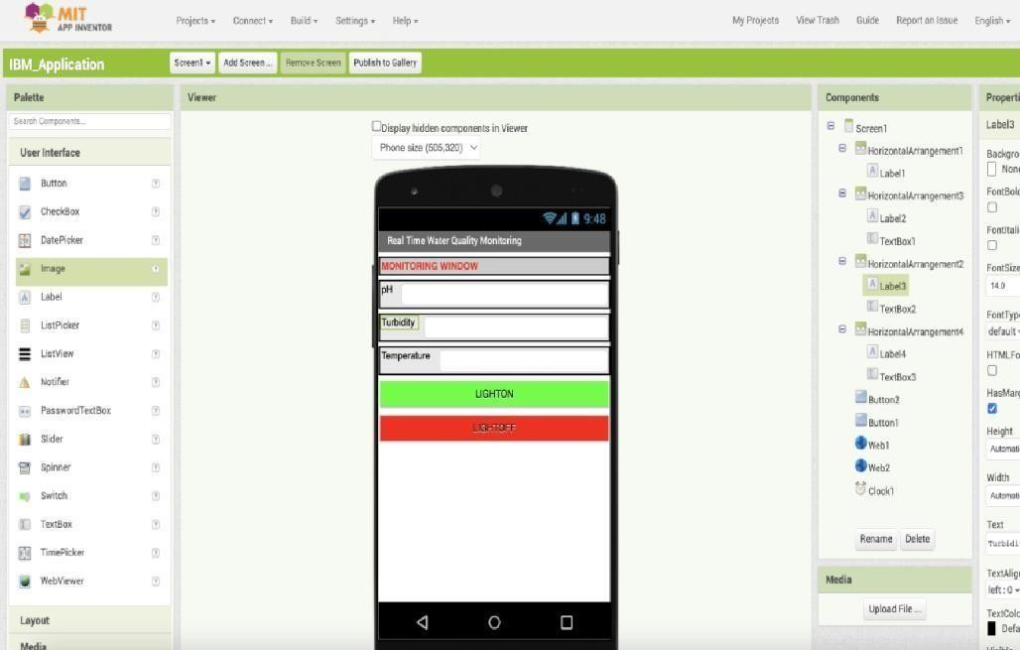

* 1. **USER ACCEPTANCE TESTING**

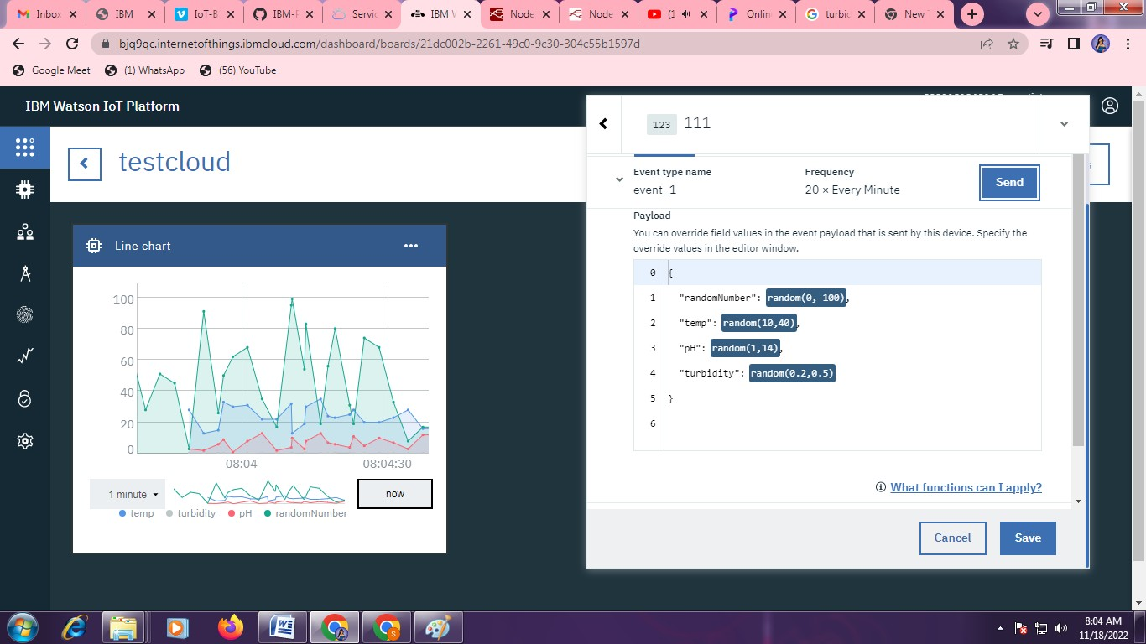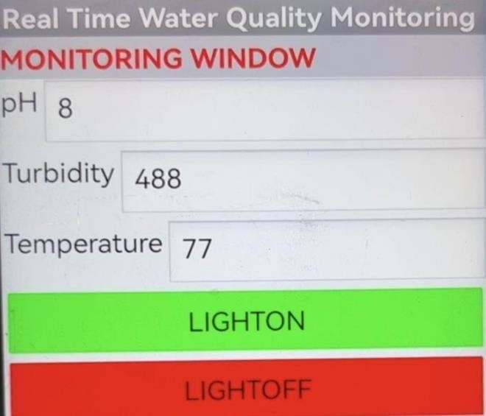

1. RESULTS

# PEFORMANCE METRICS PH VALUE:

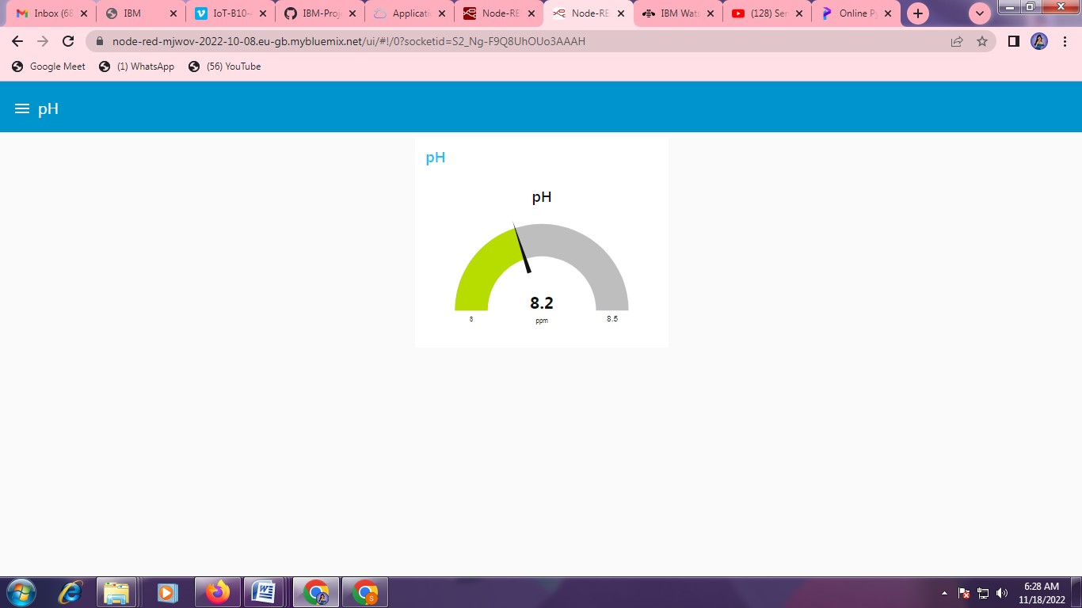

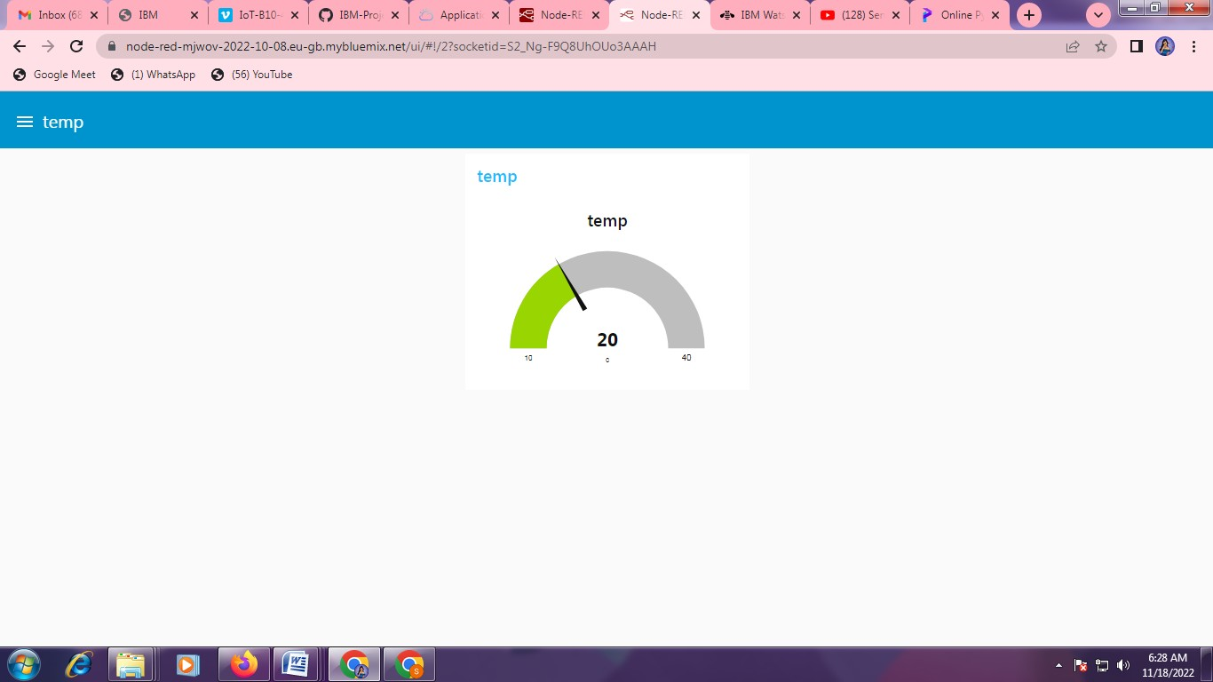**TEMP VALUE:**

# TURBIDITY VALUE:

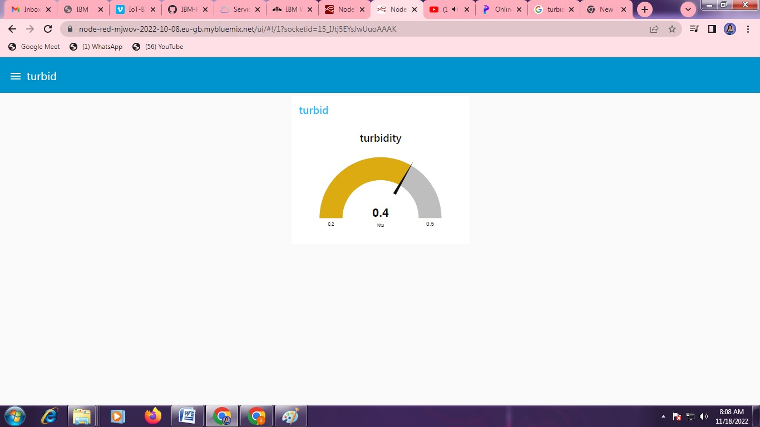

1. ADVANTAGES & DISADVANTAGES

* Benefits or Advantages of IoT based Water Quality Monitoring System

Following are the benefits or advantages of IoT based Water Quality Monitoring System are as follows.

➤The boat is mobile in nature and hence large number of samples are easily collected from different locations in less time.

➤It is very easy to maintain the IoT based water quality monitoring system as all the electronic boards are available in the boat itself.

➤The system is very cheap as the hardware and software does not cost much.

➤Machine learning techniques have made it very easy to plot the data collected in various formats for proper analysis.

➤Cloud storage platforms such as adafruit, azure helps in storing the sensor data immediately and wirelessly to the robust servers.

* Disadvantages Of IoT Based Water Quality Monitoring System
  + Drawback is that **it is costly because of using smart sensors**; also, the size of sensors is not reliable for water tap. Water pollution increases due to chemical and biological wastes.

1. CONCLUSION

In this work, the design and demonstration of a prototype remote, automatic, portable, real time, and low cost water quality monitoring system is described. In this system, low cost components

i.e. microcontroller, LCD screen and other components are used to achieve the objectives of the proposed design with acceptable accuracy.

Compared to the previous related works, the cost of the system prototype is considerably low. Toensure the portability of the device, a self-made, small size Arduino microcontroller is used. The developed system was tested under different conditions, with solution of water with different impurities, and in different periods of time.

The results of the test for all times have been successful. We conclude that all the objectives of the proposed system have been achieved. To test more parameters of the water quality for some applications, other sensors can be included in the system. The system has wide application and it is usable and affordable by all categories of users.

1. FUTURE SCOPE

The future scope of this project is monitoring environmental conditions, drinking water quality, treatment and disinfection of waste water etc. This system could also be implemented in various industrial processes. The system can be modified according to the needs of the user and can be implemented along with lab view to monitor data on computers.

1. APPENDIX

APPENDIX B: AUTOMATIC WATER QUALITY MONITORING

B1. General considerations

The analytical methods employed with automatic water quality monitors (or on-line instruments) are, in the main, fundamentally the same as those used in the laboratory. The main difference between laboratory instrumentation and on-line instrumentation is to do with the robustness of construction and the addition of automatic systems for sample preparation, instrument/sample line cleaning and instrument calibration.

In an ideal world, an on-line chemical analyser would employ low cost non-invasive measurement techniques, produce highly accurate results and never need servicing. In reality a target of achieving results of acceptable accuracy at an acceptable cost, with a service requirement not greater than once per week is likely to be more appropriate. To achieve this, the main features required in an automatic water quality monitor are:

1. appropriate location of sampling point;
2. purpose-designed robust construction, both in terms of the physical protection provided by the instrument housing and the robustness of the operational methodology;
3. tolerance to the extremes of temperature likely to be encountered;
4. resistance to the ingress of dust and water;
5. tolerance of electromagnetic fields, electrical transients and power supply disturbances;
6. minimum supervision and maintenance requirements;
7. designed for easy access and fault-finding when maintenance is required;
8. purpose-designed sample transport and conditioning system.

The two main applications are for monitoring or control. In general, monitoring applications require predictable, long-term analytical performance in terms of accuracy and reproducibility to ensure comparability of the data. On the other hand, fast response time and high sample throughput rates are not usually an issue. In contrast, analysers used in process control applications often have to respond rapidly and reproducibly to small changes in the composition of the process fluid, whereas absolute accuracy is often of lesser importance.

The choice of analysis method and hence instrument has to be made with due regard for the use to which the resulting data will be put. For example, instruments based on well documented colorimetric methods can provide data of predictable and consistent quality. However, depending on the inherent delay in the chemistry involved, they tend to have fairly long response times from the sample entering the analyser to the output of the result. Instruments based on such methods may, therefore, be less than ideal in control applications requiring a fast response, but are suited to monitoring applications. In contrast, electrochemical analysers are less predictable in their performance, thus requiring frequent recalibration. However, their relatively rapid response to changes in the sample stream composition is often an important consideration in process control applications.

The degree of complexity inherent in any given analyser installation is dependent on both the complexity of the measurement technique and the nature of the sample. As an example, the on-line measurement of conductivity can be easily and reliably performed on a wide range of sample types using a non-contact measurement technique. In contrast, the measurement of determinants such as phenol, on a treated or partially treated waste effluent, is fraught with difficulty and requires a high level of operator input.

The basic measuring techniques which are in general on-line use are physical, electrochemical and photometric. Examples of the range of determinants for which on-line analysers based on these techniques are available, are listed below.

* 1. Physical: colour, turbidity, suspended solids, conductivity, pressure, depth, level, density, temperature, flow rate, volumetric flow.
  2. Electrochemical: pH, ammonia, nitrate, bromide, calcium, carbon dioxide, chloride, chlorine, metals, cyanide, fluoride, REDOX, dissolved oxygen.
  3. Colorimetric: ammonia, nitrate, nitrite, phosphate, chloride, fluoride, sulphate, metals, manganese, phenols.
  4. Other measurement techniques which are available on-line include: high temperature and low temperature methods for organic carbon measurement; respirometry for BOD and toxicity; and gas chromatography and HPLC for phenols and organics.

Dedicated analysers are available for many of these determinants, but in situations where this is not the case, then a user configurable analyser can be used. Such analysers, often referred to as 'process titrators' or 'process analysers', are available from a number of manufacturers. These instruments consist of a programmable controller and a selection of valves, pumps, sample- conditioning devices and sensor options. The flexibility offered by these analysers enables laboratory methods based on titrimetric, colorimetric and electrochemical techniques to be operated on-line.

There are three basic types of process analyser configuration, two of these are continuous flow systems and the third is a batch process in which measured volumes of sample are processed in a series of discrete steps on a continuous basis. The time interval between each analysis is usually user selectable, with a minimum value which is a function of the design of the instrument and the method of analysis. These analysers are usually constructed in a modular form to facilitate simple adaptation to a wide range of analytical methods.

The selection and installation of an on-line analyser should be approached in a similar way to that employed in the selection of appropriate laboratory methodology/instrumentation. The application should be identified in terms of the:

1. determinant to be measured;
2. reason for making the measurement;
3. required frequency of the measurements;
4. consequences of analyser failure;
5. composition of the sample;
6. accessibility of a suitable sampling point; and,
7. availability of suitable locations for the analyser installation.

Using this information, the analyser performance requirements should be defined and the sample conditions identified. Points to be considered include:

1. The performance required i.e. systematic error, random error, specificity, limit of detection and response time;
2. The environment in which the analyser will be installed and hence the degree of environmental protection required. If an appropriately protected analyser is not available then additional protection may have to be provided;
3. The electrical environment in which the analyser will be operated. A poor quality electrical supply, the close proximity of heavy electrical plant or sources of electromagnetic radiation may necessitate the installation of power supply conditioning equipment or additional shielding;
4. The requirements for sample transport and conditioning prior to analysis. Limitations on the acceptable range of sample composition at the input to the analyser may necessitate additional sample conditioning to be undertaken. The delays which are likely to occur within the proposed sampling and analysis system should be estimated and compared with the identified measurement response time requirements to ensure that the installation is capable of meeting the requirements.

Sampling systems play a very necessary and vital role in the successful operation of on-line analysers. Unless the sensor is located directly into the waterbody there is a requirement to convey the sample to the analyser. Even in the case of sensors inserted directly into the waterbody the location of the sensor is crucial in obtaining representative results.

There is a temptation to view the sampling system as simply a method of transporting the sample from the waterbody to the analyser, without considering all the potential implications. This can lead to a number of problems occurring:

1. significant changes in the composition of the sample within the sampling system giving rise to unrepresentative results;
2. insufficient sample flow or long delays between the sample being extracted from the waterbody and delivered to the analyser;
3. the sample line becoming blocked;
4. failure of the instrument to live up to expectations or being considered to be unreliable and hence gradually falling into disuse.

It is clear that the sampling system is an integral part of the installation which must be taken into account early in the design stage if the overall objectives are to be met.

The choice of which system to apply will depend on a number of factors such as:

1. the separation between the analyser and the sampling point;
2. the system response time requirements;
3. the consequences of changes occurring in the sample; and,
4. the nature and composition of the sample.

The design of the sampling system should encompass the design objectives listed below. The priority assigned to each of these objectives will depend on the details of the specific application.

1. Representative sampling: The sample that is delivered to the instrument should be representative of the process stream with respect to the determinants being measured.
2. Compatibility: The sample should be presented to the analyser in a state which is compatible with the measurement technique used by the analyser.
3. Sample transport delay: The design of the sample system should take account of the inherent time lag, between the sample being taken from the waterbody and delivered to the inlet to the analyser, so as to ensure the overall response time objectives can be met.
4. Reliability: The sampling system should be reliable and require the minimum of maintenance. If necessary automatic back flushing and/or air purge can be employed, along with a duty and standby system.
5. Safety: The sampling system must be safe to operate and maintain.
6. Validation: The system should be designed with grab sample tapping points at suitable locations to facilitate system validation both at the commissioning stage and routinely during its operational life.

GITHUB &PROJECT DEMO LINK

https://github.com/IBM-EPBL/IBM-Project-36228-1660293541

https://youtu.be/LBCVX1wB7as